**Computer Vision & Image Processing**  
Task 2: Sketch effect using High Pass Filter

Nama : Luthfi Aminulloh

NRP : 1020181013

Kelas : TE2018

**HPF – Metode Prewitt**

* Metode Prewitt adalah metode deteksi tepi hasil pengembangan dari metode Robert dengan memanfaatkan 8 titik tetangganya.
* Metode Prewitt menggunakan filter kernel:

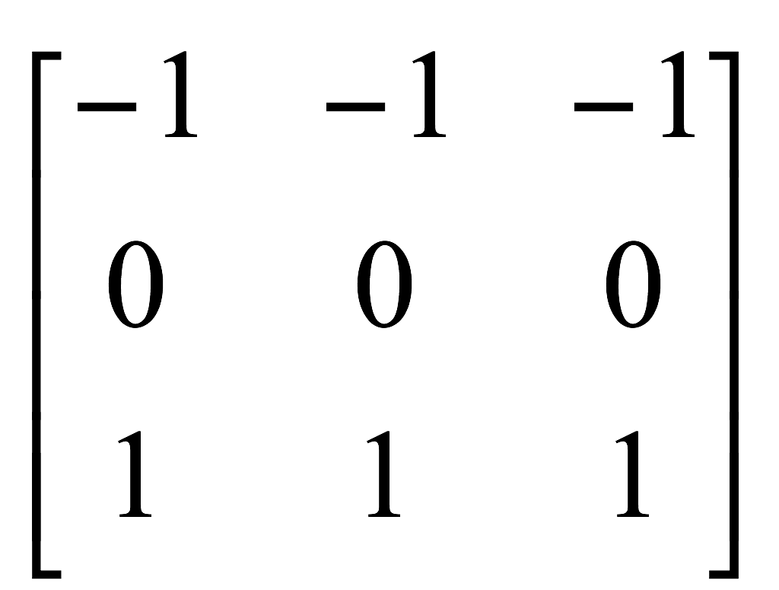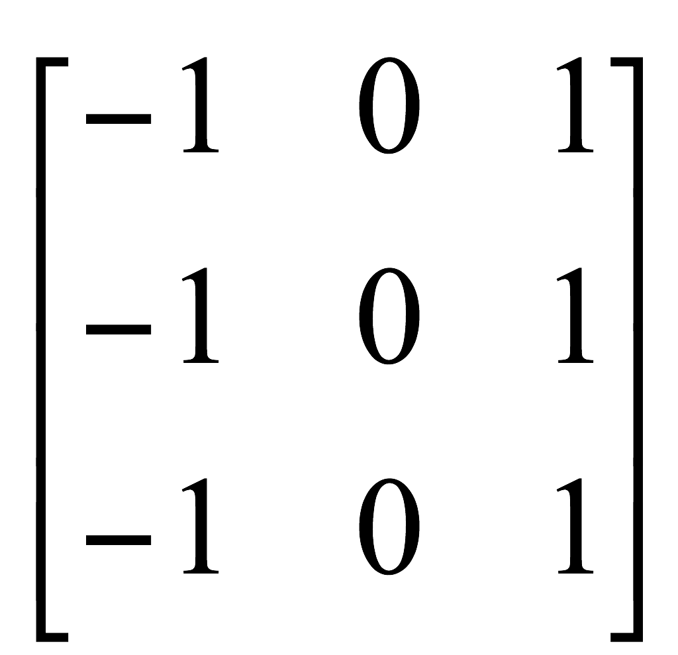

$V={({Gx}^{2}+{Gy}^{2})}^{\frac{1}{2}}$

|  |
| --- |
| **Listing Program:** |
| %------ Program untuk membersihkan nilai variable -----%  clc;  clear all;  %-----------------Program Utama -----------------------%  a = imread('flower.jpg');  x = rgb2gray(a);  %----------------HPF Prewitt Masks---------------------%  px = [-1 0 1; -1 0 1; -1 0 1];  icx = filter2(px,x);  py = px';  icy = filter2(py,x);  pedge=sqrt(icx.^2+icy.^2);  %-----------------End Prewitt--------------------------%  %-----------------Low Pass Filter----------------------%  prewit = uint8(pedge);  %LPF dengan karnel 5x5  LFP = imfilter(prewit, ones(5)/25, 'symmetric');  %merubah gambar ke nilai negatif (inverse)  hasil = 255-LFP;    figure(1) %Menampilkan gambar proses Prewitt Filter  subplot(1,3,1),imshow(icy/255),title('HPF Horizontal (X-axis)');  subplot(1,3,2),imshow(icx/255),title('HPF Vertical (Y-axis)');  subplot(1,3,3),imshow(pedge/255),title('HPF Prewitt');    figure(2) %Menampilkan gambar perbandingan original vs sketch  subplot(1,2,1),imshow(x),title('Original Image');  subplot(1,2,2),imshow(hasil),title('Sketch Effect');  %----------------- Akhir Program -----------------------% |

|  |
| --- |
| Percobaan Gambar 1. |
|  |
|  |

|  |
| --- |
| Percobaan Gambar 2. |
|  |
|  |